Design Document
Table of Contents
- System Overview
- Implementation Details
- Use Case Support in Design
- Design Decisions

Writers
- Tenay Giray
- İpek Atak
- Defne Saracel
- Nehir Adak

- System Overview
Brief Project Description:
In this project we are aiming to raise environmental awareness with our web application “Planeta”. Planeta is a progressive web application that tracks individuals’ daily activities with daily surveys. It provides appropriate feedback according to their answers and score. It helps users to see their progress with weekly/monthly reviews that encourage them to be more consistent with their act.

To keep users’ enthusiasm alive, beside score ranking system it also awards users with badges at milestones. Planeta offers simple user interface with daily enlightening quotes about nature. It promotes sustainable use of natural resources in an interesting way.

System Architecture:
Planeta designed to follow a client-server model where the Flutter application acts as the client and Firebase acts as the server (BaaS). This serverless approach enables system to handle authentication and data storage in a simple way.
The system is structured by layered architecture. Instead of a traditional Repository pattern, Planeta utilizes Interface-based Service Abstraction. Business logic components interact with abstract service classes. The actual Firebase implementation injected at runtime. This approach minimizes the “Vendor Lock-in” by decoupling the UI from the specific Firebase SDK.

- Presentation Layer:
The user interacts with web application through this layer. We decided to use Flutter to build our user interface. This layer handles UI, mode switching and local state management. It triggers authentication and data processes by communicating with the service layer.

- Service Layer:
This layer is the brain of the application; it acts like a bridge between presentation and database layer. It handles raw data to transform into meaningful results. This layer is responsible for score calculation, choosing accurate feedback according to result, controlling milestones and rank situations, business logic validation and so on.

- Database Layer:
For database layer we use “Cloud Firestore” a NoSQL document database. It helps system to store user profiles, daily survey results, earned badges and ranks while enabling real time updates. Service layer processes the data fetched from Firestore which resides here.

Technology Stack:
- Frontend Framework: Flutter
- Authentication System: Firebase Auth
- Backend / Database: Cloud Firestore
- State Management: Provider (Flutter Library)
- Design: Flutter (Material Design 3)
- Deployment: Web (Firebase Hosting/ GitHub Pages)
- Platform: Modern Web Browser (Chrome, Edge)

Component Diagram of Planeta System Architecture:
This diagram illustrates the high-level decomposition of the system. By utilizing standardized interfaces (APIs) between components, the architecture ensures modularity.

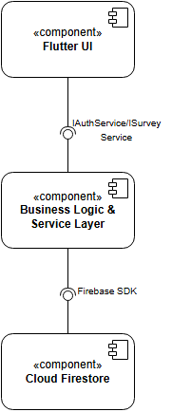

Deployment Diagram of the Planeta System:
This deployment diagram illustrates the cloud-native distribution of the web application.

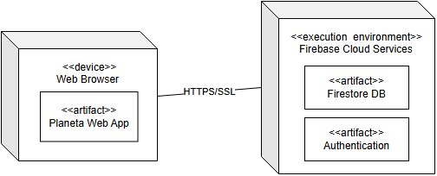

Design Patterns and Architectural Decisions
This section outlines architectural challenges encountered during the development of Planeta and the specific design patterns implemented to solve them. Each decision is evaluated based on software quality factors and its impact on the system’s structural integrity.
- Resource Management and Global Service Access
Multiple UI components (login, register, history) require access to the AuthService and SurveyService. Creating a new instance of these services in every widget leads to redundant memory consumption and potential data inconsistency across different parts of the web application.

Solution: Singleton Pattern, implemented in all classes within lib/services/ such as AuthService and SurveyService.

Quality Factors & Criteria
By ensuring only one instance of each service exists in memory, the system optimizes RAM usage for the web browser environment.
Centralizing the service instance guarantees that the authentication state and survey data remain consistent across the entire web application lifecycle.

- Decoupling and Provider Independence
Direct dependency on the Firebase SDK within the UI or core business logic creates a “Vendor Lock-in” scenario. If the project needs to migrate to a different backend the entire codebase would require significant refactoring.

Solution: Interface Segregation / Strategy Pattern

Quality Factors & Criteria
Decoupling the business logic from the specific database implementation allows for easier debugging and isolated testing.
By depending on abstractions rather than concretions, the web application remains flexible. Switching the underlying data provider only requires a new implementation of the interface, leaving the UI layer untouched which also demonstrates “Open-Closed Principle” from SOLID.

Class diagram of Authentication module:
This class diagram illustrates the Strategy Pattern via IAuthService abstraction, ensuring UI decoupling from the Firebase SDK. Additionally, the Singleton Pattern is applied to FireBaseAuthService to manage system resources efficiently.

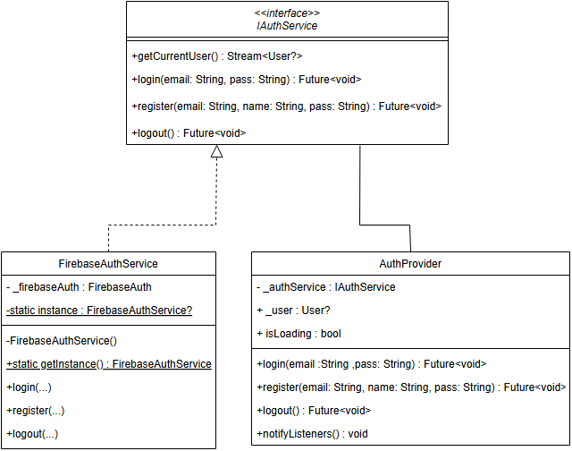
Class diagram of Survey & Scoring module:
This diagram demonstrates a clear “Separation of Concerns” by isolating the scoring logic in ScoreCalculator from the data persistence handled by ISurveyService. The architecture maintains modularity and high maintainability by ensuring the SurveyProvider depends solely on abstractions rather than concrete database implementations.

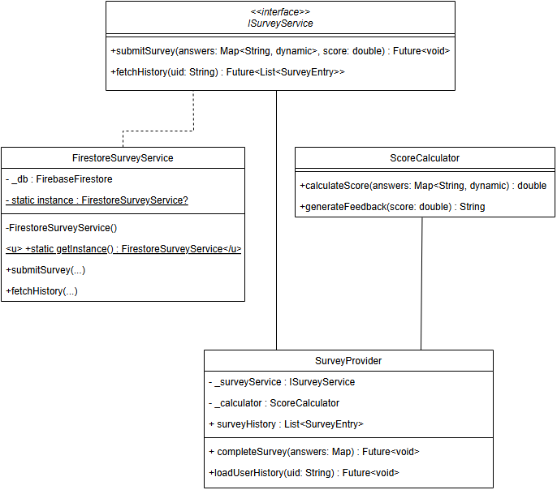

Domain model and Data Entity Relationships:
This diagram represents the core data entities and their structural relationships. It defines how a User linked to multiple SurveyEntry and Award objects in one-to-many relationships, illustrating the hierarchical data structure designed for NoSQL backend.

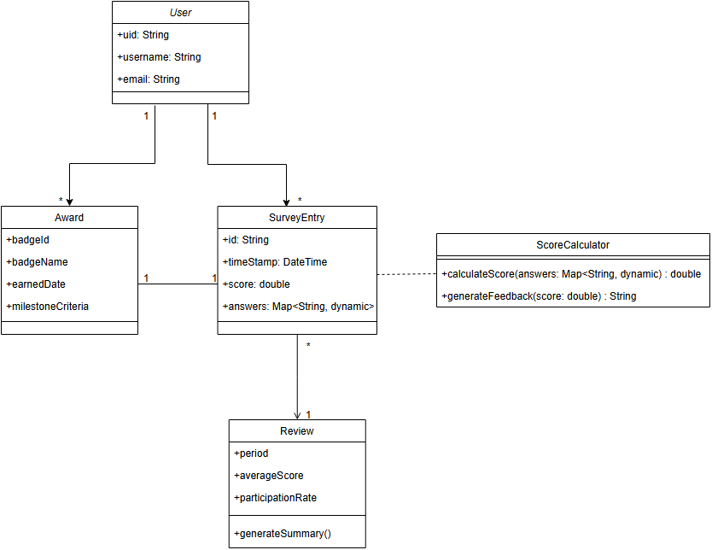

- Implementation Details

2.1 Codebase Structure
“Planeta” will have three layers (Presentation, Service and Database Layer). The codebase structure:
lib/
├── main.dart # Firebase initialization + Provider setup
├── app.dart # MaterialApp configuration (routes, theme)

├── models/ # DATABASE LAYER – Firestore data models
│ ├── user_model.dart
│ └── survey_model.dart

├── services/ # SERVICE LAYER
│ ├── providers/ # state management
│ │ └── auth_provider.dart
│ │ └── survey_provider.dart
│ │ └── review_provider.dart
│ │

│ ├── auth/
│ │ └── auth_interface.dart
│ │ └── auth_service.dart # login and register
│ │

│ ├── firestore/ # database access
│ │ └── database_interface.dart
│ │ └── user_service.dart
│ │ └── survey_service.dart
│ │
│ └── logic/
│ ├── score_calculator.dart
│ └── review_generator.dart

├── screens/ # PRESENTATION LAYER- UI screens
│ ├── auth/
│ │ ├── login_screen.dart
│ │ └── register_screen.dart
│ ├── home/
│ │ └── home_screen.dart
│ ├── survey/
│ │ └── survey_screen.dart
│ └── history/
│ └── history_screen.dart

├── widgets/ # PRESENTATION LAYER- reusable UI components
│ ├── common/
│ │ ├── custom_button.dart
│ │ └── theme_toggle.dart
│ ├── survey/
│ │ └── survey_question.dart
│ └── history/
│ │ ├── history_item.dart
│ │ └── badge_item.dart
└── utils/ # shared configurations and helpers
├── app_constants.dart
├── app_theme.dart

2.2 Key Implementations
This section describes the core logic and technical mechanisms for the functional requirements of Planeta application:
UI Layer → Service Layer → Firebase Backend

Hybrid Scoring and Feedback Engine:
This is the core business logic that processes daily surveys. It supports both binary (Yes/No) and Likert-scale (5 option) answers by assigning points (0/100 for binary answers ; 0,25,50,75,100 for Likert answers) to calculate a final sustainability score. Based on the result, it triggers a rule-based feedback system to provide users environmental advice.
finalScore = totalPoints / numberOfQuestions;

Award Logic:
This module manages the Award System by analyzing the user’s historical survey scores stored in the database. When the cumulative score reaches predefined thresholds, the system automatically grants the user a new rank. This ensures that users are rewarded for their long commitment and consistent sustainable performance over time. When predefined thresholds are reached, the user is automatically promoted to a higher sustainability rank.
Provider-Driven State and Theme Management:
Using the Provider pattern, the web app manages real time state changes, such as survey progress and authentication status.
Firebase Authentication and Profile Integration:
This module implements the logic for secure user registration and login functionality. We want users to be able to sign up for a new account and log in with their existing information.
History Tracking Management:
Every submitted survey is stored as a timestamped document in a Firebase. This architecture enables users to view their historical surveys, scores, and dates through the “User History” screen.
Each submitted survey is stored as a timestamped document under:
class SurveyEntry {
final String id;
final DateTime timestamp;
final Map<String, dynamic> answers;
final int score;
final String feedback;
}

2.3 Component Interfaces
1)Presentation Layer:
UI Components (Widgets):
- SurveyQuestionsWidget:
  - A reusable interface component that creates individual questions captures input according to the defined scaling system.

- CustomButton:
  - A standardized button used across Login,Register and survey screens for consistent UX.

2)Service Layer (SurveyProvider&AuthProvider):
This layer handles both the scoring algorithms and direct communication with the cloud backend. It eliminates the need of separate Repository layer by utilizing the Firebase SDK directly.
- submitSurvey(Map<String,dynamic> answers):
  - Triggers the scoring algorithm (Hybrid Scoring) and generates feedback message based on the result. Calls Database Layer (Firebase) to persist the entry.

- loadHistory():
  - This function finds the user’s past survey results from Firestore. It organizes them from newest to oldest using timestamps and refreshes the list on the screen. After getting the data from the database, the app puts this new information into the list so the user can see it.

- Future<User> register( String email, String password, String username):
  - Calls Firebase Auth to create credentials and initializes a user a document in Firestore.

- Future<User> login( String email,String password):
  - Authenticates the user and detects the profile from users list.

- logout():
  - Clears the local session and returns the user to the Login screen.

  - Login, register, and logout operations are triggered from the Presentation Layer and handled by the Service Layer.

3) Cloud Database Layer (Serverless Backend)
For the database layer, the application utilizes Cloud Firestore, a serverless NoSQL database provided by the Google Firebase platform. It helps our system to store user profiles, daily survey results, earned badges, and ranks while enabling real-time updates.
Data Storage: Every survey the user completes is saved as a document with a timestamp in the cloud.
Encapsulated Data Access: The Service Layer implementations encapsulate the Firebase SDK calls, preventing UI components from interacting directly with the database.

2.4 Visual Interfaces
Login Screen:
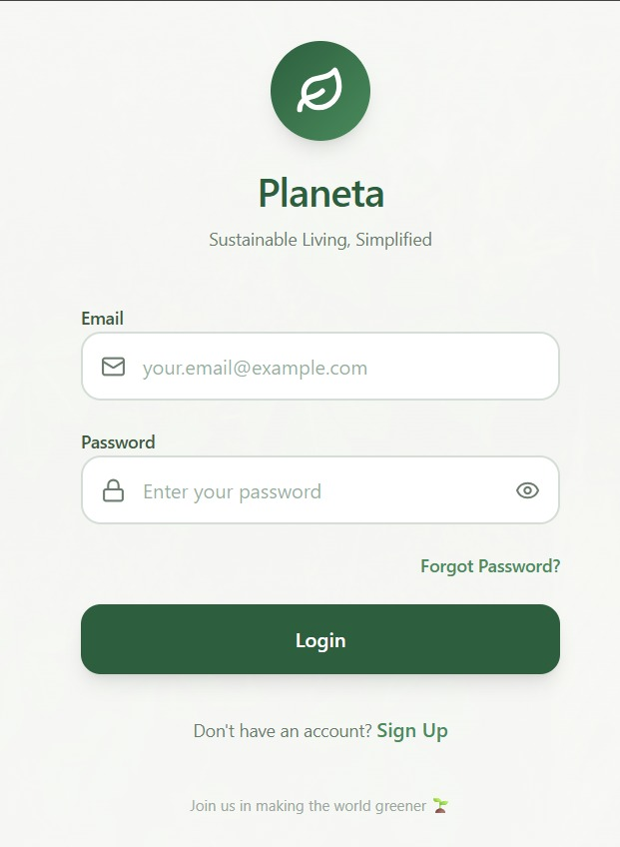
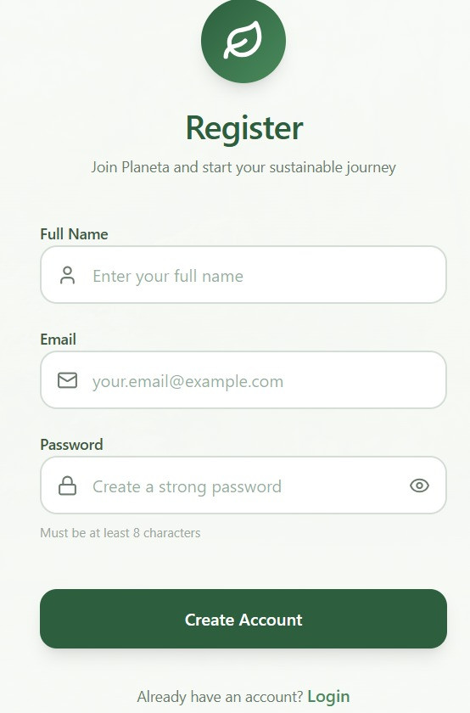
Register Screen:
Home Screen:

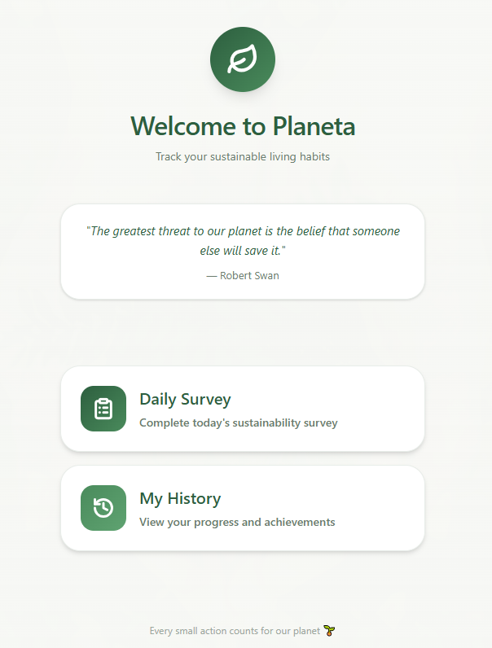
Survey Screen:
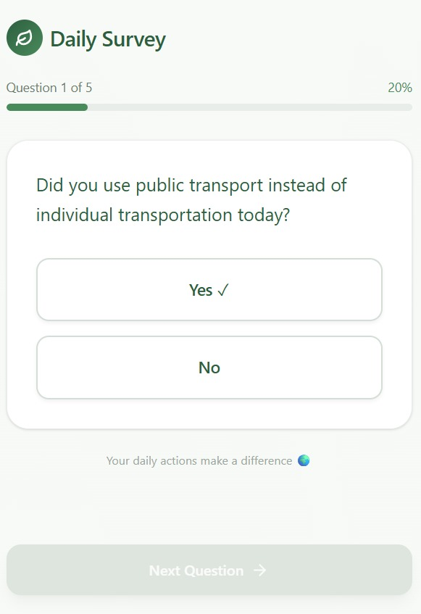
History Screen:
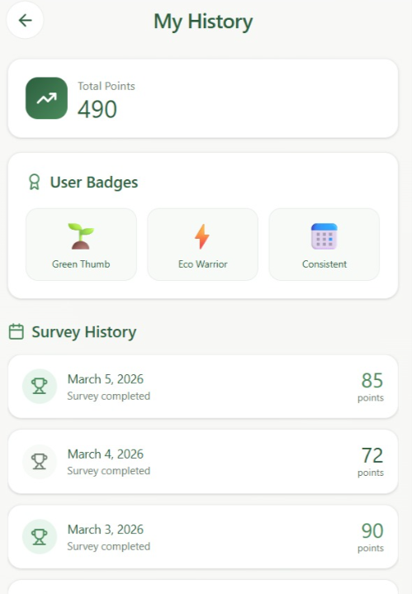
3)Use Case Support in Design
3.1 Use Case Selection:
- UC1 - User Registration(Sign Up)
- UC2 - User Login(User Authentication)
- UC3 - Daily Survey Submission + Providing Feedback
- UC4 - Survey History
3.2 Requirement Mapping:
 | Use Case | Requirements
UC1 | User Registration | - User Account
UC2 | User Login | - User Authentication
UC3 | Daily Survey Submission + Providing Feedback | - Daily Survey  - Feedback System
UC4 | Survey History | - Survey History

3.3 Use Case Desing:
The interaction pattern follows a decoupled layered architecture.
Flutter UI -> Provider (State Management) -> Service Interface (Abstraction)-> Firebase Implementation -> Provider Updates State -> UI refreshes
UC1 - User Registration(Sign Up): Create a new user account
System Architecture Support:
- Flutter UI (Register Screen) takes email/username/password.
- Auth Service layer (IAuthService) creates the user credentials.
- Data layer (Firestore) stores user profile document (username, email, createdAt).

Sequence Diagram (Data Flow / Interactions):
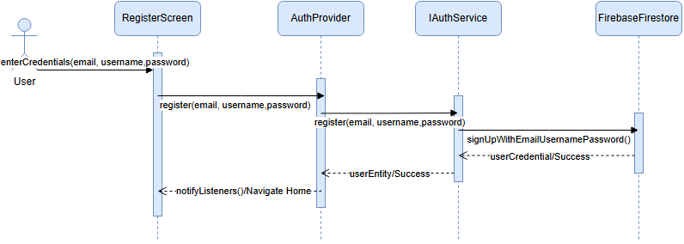
State Changes:
- Web App State: unauthenticated -> authenticated
- Database State: new document created in users collection for that uid.
- Local State: Provider store new userEntity.

UC2 - User Login (User Authentication): Login with existing credentials
System Architecture Support:
- Flutter UI (Login Screen) takes credentials.
- Auth Service Layer(IAuthService) manages authentication requests through an abstracted interface.
- Firebase Auth & Firestore verifies username/email and password.
- Provider updates app authentication state and current user data.

Sequence Diagram (Data Flow / Interactions):
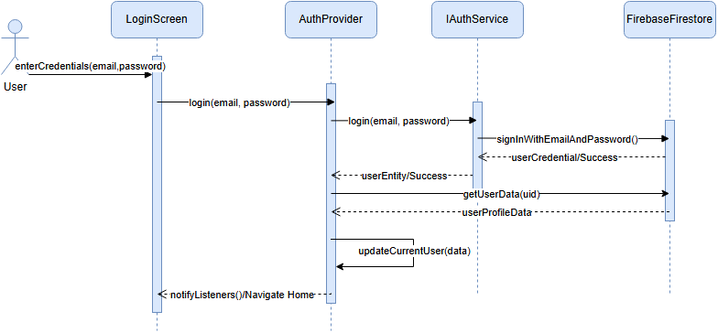
State Changes:
- App State: unauthenticated -> authenticated
- Local State: Provider stores currentUserinformation

UC3 – Daily Survey Submission and Providing Feedback: Submit answers, compute score, show feedback, store result
System Architecture Support:
- Flutter UI (Survey Screen) collects the user’s survey answers.
- Business Logic (Score Calculator) isolates the scoring logic and the feedback selection from the UI.
- Service Layer (ISurveyService) manages the submission process through an abstraction, decoupling provider from the specific database.
- Data Layer (FirebaseFirestore) stores the final survey entry under the user’s specific collention.

Sequence Diagram (Data Flow / Interactions):
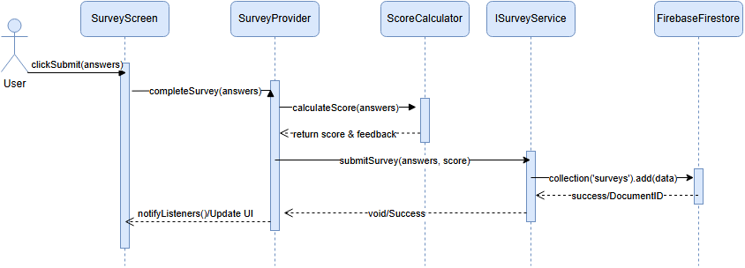
State Changes:
- Database State: new survey document created in the surveys sub-collection for the authenticated user
- UI State: surveyNotSubmitted -> surveySubmitted
- Local State: SurveyProvider updates its local cache include the new entry without needing a full refresh
UC4 – Survey History: Displays previous surveys with date and score
System Architecture Support:
- Flutter UI (History Screen) initiates the request to view past survey entries
- State Management (SurveyProvider) orchestrates the data flow and holds the list of survey entities for the UI
- ServiceLayer (ISurveyService) acts as an abstraction layer to fetch historical data, ensuring the provider is not tightly coupled to Firestore
- Data Mapping, the service layer transforms raw database documents into SurveyEntity objects via mapDocsToEntities to maintain a clean domain model
- Data Layer (FirebaseFirestore ) executes the specific query that ordered by timestamp to retrieve the user’s survey documents

Sequence Diagram (Data Flow / Interactions):
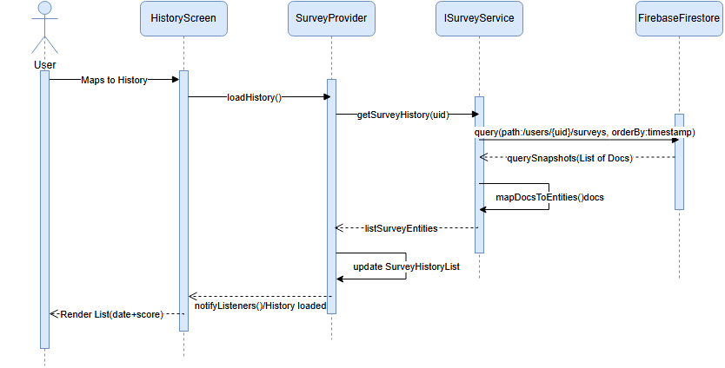
State Changes:
- Database: Read Only
- Local State: SurveyProvider updates surveyHistoryList and triggers notifyListeners()
- UI State: Transitions from a loading state to a rendered list view showing dates and scores

3.4 Demo Requirement:
The four use cases as stated above will be fully implemented and demonstrated during the final project presentation.

4)Design Decisions
Technology Comparisons:
1)Flutter vs React Native

Feature | Flutter | React Native
Language | Dart | JavaScript
Performance | Very High | High
UI Design | Rich built-in widgets | Uses native components
Maintained by | Google | Meta
Object Oriented Programming | Fully object-oriented | Partially object-oriented
Architecture Comparison | Direct Native Compilation | Bridge Architecture
Hot Reload | Excellent | Good

Performance Advantage
Flutter provides higher performance compared to React Native because it uses its own rendering engine (Skia) and compiles directly into native code. This eliminates the need for a bridge between the application and native components. As a result, Flutter offers faster execution and smoother user experience.

Object Oriented Structure
Flutter uses Dart, which is a fully object-oriented programming language. This allows us to use principles such as: encapsulation, inheritance, abstraction and modularity. This improves code organization and maintainability. React Native useless JavaScript, which supports object-oriented programming but is not fully object-oriented and has a more flexible structure. Therefore, Flutter provides a more structured and maintainable codebase.

UI Consistency and Customization
Flutter uses its own widget system to render UI components. This ensures that the application looks consistent and pure across different platforms. React Native uses native UI components, which may behave differently depending on the platform. Therefore, Flutter’s widget-based architecture provides better UI control, consistent design and easier customization for us while implementing Planeta.
Architecture
Flutter has a simpler architecture because it does not rely on a bridge. Instead, it communicates directly with the native platform. React Native requires a bridge between JavaScript and native code, which increases complexity and may reduce performance. We choose Flutter for simpler and more efficient architecture that improves performance, stability and development efficiency.
Hot Reload
Flutter provides a highly reliable and fast hot reload feature. It allows us to instantly see changes in the user interface without restarting the application. React Native also supports hot reload. However, it is less stable compared to Flutter and may sometimes require a full reload. In some cases, application state may not be fully preserved. Therefore, Flutter provides more efficient and reliable hot reload experience, which improves development speed and productivity.
OOP Comparison: Flutter vs React Native
Dart's classes allow for clear hierarchies and polymorphism:
abstract class PlanetaTask {
String title;
int getPoints(); // Abstract method
PlanetaTask(this.title);
}
// Inheritance and Implementation
class RecyclingTask extends PlanetaTask {
int weight;
RecyclingTask(String title, this.weight) : super(title);

@override
int getPoints() => weight * 10; // Specific logic for recycling
}
While you can use classes in JS/TS, the ecosystem leans heavily toward functional patterns:
// Usually defined as a Type or Interface in TypeScript
const calculatePoints = (taskType, value) => {
if (taskType === 'recycling') return value * 10;
return 0;
};
// Components are usually functions, not class objects
const TaskItem = ({ title, points }) => (
<View><Text>{title}: {points}</Text></View>
);
2) Firebase vs Supabase

Feature | Firebase | Supabase
Database Type | NoSQL | SQL
Open source | No | Yes
Relational data | Hard | Easy(supports foreign keys)
Real time updates | Excellent(Native feature) | Excellent
Security Modal | Firebase Security Rules(Custom) | Row Level Security(Standard SQL)
Vendor Lock In | High | Low

Open Source Status
While not open source, the Firebase Extensions and Documentation for pre-defined survey-style apps are extensive. This allows our group to implement the logic for "Fetching Questions -> Showing UI -> Saving Answers" faster than building a custom SQL schema from scratch.
Relational Data (Linking Survey Questions to Users)
We deliberately moved away from the high overhead associated with "JOIN" operations found in traditional relational databases (SQL). Instead, we utilized Firestore’s NoSQL document model to store data at /users/{uid}/surveys/{dateId} which prioritizes read speed and responsive web performance. Since Firestore queries scale with the size of the result set rather than the total dataset, our decision to use a hierarchical NoSQL structure ensures that our app remains fast and efficient even as the number of users and survey entries grows

Real-time Updates (Instant Feedback)
To support the gamification goals of the project—such as providing immediate feedback on a user's sustainability score—we leveraged Firebase’s native real-time listeners. When a user answers a pre-defined question, we want their score to update instantly. Firebase’s real-time listeners allow the UI to reflect the change the millisecond the data is written to the cloud.

Vendor Lock-in
While Firebase introduces a higher level of vendor lock-in due to its proprietary NoSQL structure and custom security rules, we prioritized development velocity for the Planeta project. To mitigate this lock-in, we decoupled our business using abstract service interfaces. This ensures that the UI and the scoring algorithms depend on abstractions rather than the concreate Firebase SDK, making the system more portable even if a database migration is required in the future.

Task Matrix

- Tenay Giray | - System Overview
- İpek Atak | - Use Case Support in Design
- Defne Saracel | - Implementation Details, Design Decisions
- Nehir Adak | - Implementation Details, Design Decisions

